2022 Fall Book Sale!
  - Friends of the Library
  - Located at the Boone County Library
Thursday September 29  9am to noon members only  Noon to 6:45pm open to the public  Friday September 30  9am to 4:45pm  Saturday October 1  Half Price  9am to 2pm | 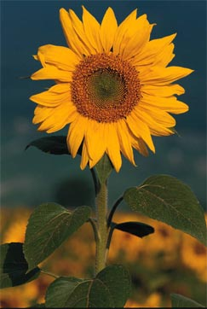

Childrens, Young Adult, Adult
fiction and non-fiction offerings
ALL proceeds go to benefit the Boone County Library

Friends of the Boone County Library, Inc.

221 W. Stephenson | Harrison, AR 72601 | 870-741-5913 | www.folbc.org

Additional directions or other information

